Space under stress

Th. Ghesquière-Diericks¹, G. Anciaux¹, V. Acary², J.F. Molinari¹

1: Department of Civil Engineering, EPFL, Lausanne, Switzerland
2: TRIPOP, INRIA, Center of University Grenoble Alpes, France

The increasing overcrowding of Earth’s orbits has become a major concern. Commercial space launches are growing rapidly, and collisions or breakups of space objects lead to an uncontrolled proliferation of debris, further congesting orbital environments. This self-reinforcing process, known as the Kessler syndrome, poses a serious threat to space operations. To assess collision risks, space agencies such as NASA and ESA rely on breakup models, which in turn depend on empirical parameters. Physics-based models of dynamic fragmentation can significantly improve these inputs.
We have developed a high-performance finite-element framework with dynamic insertion of cohesive elements to capture crack initiation, propagation, branching, and coalescence. These dynamic fragmentation simulations provide detailed statistics of fragment masses, shapes, and velocities. We will discuss how this class of models compares favorably with analytical energy-based approaches for benchmark tests such as expanding rings or spherical membranes that mimic exploding fuel tanks. Fragment mass distributions depend strongly on geometry and loading conditions. In particular, high-velocity impacts produce power-law fragment size distributions (fig. 1a), and accurate velocity statistics require a robust treatment of fragments collisions and self-contact within partially damaged cohesive elements. In the spirit of CMIS, this presentation focuses on the associated numerical challenges.
A common approach for handling contact in explicit dynamics combines extrinsic cohesive elements with penalty-based contact. While effective over short time scales, we show that this method leads to exponential energy growth and artificial fragmentation at longer times. We present a systematic analysis of the sources of instability [1], identifying three dominant mechanisms: (i) excessively large initial cohesive stiffness, which restricts the stable time step; (ii) discontinuous stiffness jumps at the cohesive–contact interface; and (iii) discontinuities introduced by cohesive softening. Analytical error estimates, phase-space analysis, and energy growth metrics demonstrate that repeated switching between cohesive and contact states accumulates small per-step errors into a significant long-term energy drift. Within the explored parameter space, stability can only be maintained using time steps far below conventional limits. To reduce these artifacts, we evaluate an adaptive penalty strategy that links the contact stiffness to the evolving cohesive stiffness (fig. 1b). Although this approach restores energy conservation by removing stiffness discontinuities, it permits larger interpenetrations and is therefore better suited as a diagnostic tool than as a definitive solution. Overall, our findings show that penalty-based contact is not suitable for long-term, energy-consistent fragmentation simulations with physically meaningful fragment statistics.
To overcome these limitations, we propose an impulse-based contact formulation that explicitly accounts for the non-smooth nature of contact mechanics. The method is embedded implicitly within an explicit time-integration framework using the non-smooth Newmark-β scheme of Chen et al. [2]. Applied to one-dimensional dynamic fragmentation problems, this approach restores energy conservation and substantially improves robustness and accuracy in long-term simulations. Although the implicit contact resolution introduces additional computational cost, the enhanced stability enables larger time steps, resulting in overall performance comparable to—or even exceeding—that of penalty-based methods. These results demonstrate the potential of impulse-based contact as a reliable and efficient alternative for long-term dynamic fragmentation simulations.

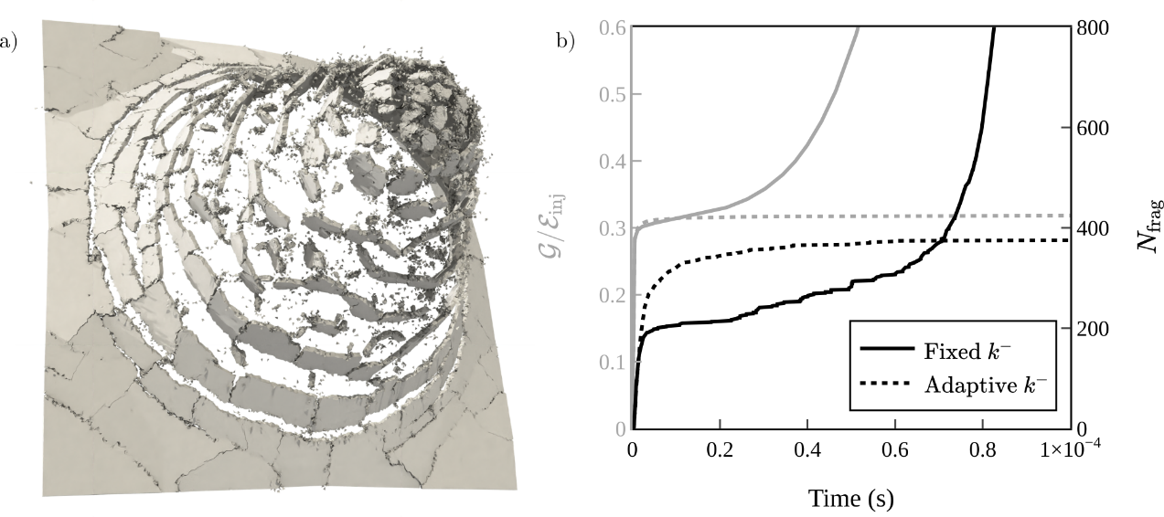Figure 1: a) Finite-element simulations of debris creation due to impact using the open-source software Akantu. The image shows numerous cracks generated using extrinsic cohesive elements. The lead to small fragments at the impact zone, surrounded by concentric cracks. b) Comparison of the number of fragments (black) and the energy dissipation during decohesion process (grey), between the fixed contact penalty k⁻ approach (solid lines) and the adaptive one (dashed lines), that ties the penalty to the cohesive stiffness, thereby removing the cohesive-contact discontinuity. The adaptive approach removes the main source of instability, resulting in a stable plateau for both the number of fragments and energy dissipated, but comes with higher interpenetration, reducing the physical accuracy of contact.

References
[1] Th. Ghesquière-Diérickx, J.F. Molinari, G. Anciaux, Stability of extrinsic cohesive-zone model with penalty-based contact in explicit dynamic fragmentation simulations, arXiv:2511.14323 , 2025.
[2] Q.Z. Chen, V. Acary, G. Virlez, O. Brüls, A nonsmooth generalized‐α scheme for flexible multibody systems with unilateral constraints, International Journal for Numerical Methods in Engineering, 96(8), 487-511, 2013.

